CITY OF FRESNO  NOTICE OF INTENT TO ADOPT A  MITIGATED NEGATIVE DECLARATION | Filed with the  FRESNO COUNTY CLERK  2220 Tulare Street, Fresno, CA 93721
ENVIRONMENTAL ASSESSMENT FOR DEVELOPMENT PERMIT APPLICATION NO. P26-XXXXX
APPLICANT:
Applicant Name
Applicant Title
Street Address
City, State, Zip Code
PROJECT LOCATION:
[Street Address]; Located on the north side of East Street Avenue between North Street Avenue and North Street Street in the City and County of Fresno, California (See Exhibit A - Vicinity Map)

APN: XXX-XXX-XX

Site Latitude: XXºXX’XX” N & Site Longitude: XXºXX’XX” W
Mount Diablo Base & Meridian, Township XXX, Range XXX, Section XX
The full Initial Study is on file in the Planning and Development Department, Fresno City Hall, 3rd Floor, Room 3043, 2600 Fresno Street, Fresno, CA 93721.
PROJECT DESCRIPTION:
Development Permit Application No. P26-XXXXX was filed by ___ of ___ on behalf of _____ and pertains to ± __ acres of property. The applicant proposes ______.
The City of Fresno has prepared an Initial Study of the above-described project and proposes to adopt a Mitigated Negative Declaration.

Pursuant to the California Environmental Quality Act (CEQA) Guidelines §§ 15070 to 15075, and 15150, this project has been evaluated with respect to each item on the attached Appendix G/Initial Study Checklist to determine whether this project may cause any additional significant effect on the environment. After conducting a review of the adequacy of the Project Specific Mitigation Measure Checklist and CEQA Guidelines §§ 15097, the Planning and Development Department, as lead agency, finds that no substantial changes have occurred.

The completed Appendix G/Initial Study Checklist, its associated narrative, technical studies and mitigation measures reflect applicable comments of responsible and trustee agencies and research and analyses conducted to examine the interrelationship between the proposed project and the physical environment. The information contained in the project application and its related environmental assessment application, responses to requests for comment, checklist, Initial Study narrative, and any attachments thereto, combine to form a record indicating that an Initial Study has been completed in compliance with the State CEQA Guidelines.

All new development activity and many non-physical projects contribute directly or indirectly toward cumulative impacts on the physical environment. It has been determined that the incremental effect contributed by this project toward cumulative impacts is not considered substantial or significant in itself and/or that cumulative impacts accruing from this project may be mitigated to less than significant with application of feasible mitigation measures.

With mitigation imposed under the Project Specific Mitigation Measure Checklist, there is no substantial evidence in the record that this project may have additional significant, direct, indirect or cumulative effects on the environment that are significant. The Planning and Development Department, as lead agency, finds that no substantial changes have occurred.

Based on the evaluation guided by the Appendix G/Initial Study Checklist, it was determined that there are [no] project specific foreseeable impacts which require project level mitigation measures.

The Initial Study has concluded that the proposed project will not result in any adverse effects, which fall within the "Mandatory Findings of Significance" contained in § 15065 of the State CEQA Guidelines. The finding is, therefore, made that the proposed project will not have a significant adverse effect on the environment.

Public notice has been provided regarding staff’s finding in the manner prescribed by § 15072 of the CEQA Guidelines and by § 21092 of the PRC Code (CEQA provisions).

Additional information on the proposed project, including the Project Specific Mitigation Measure Checklist, proposed environmental finding of a Mitigated Negative Declaration and the Initial Study may be obtained from the Planning and Development Department, Fresno City Hall, 2600 Fresno Street, 3rd Floor, Room 3043, Fresno, California 93721 3604. Please contact Planner Name at (559) 621-XXXX or via email at First.LastName@fresno.gov for more information.

ANY INTERESTED PERSON may comment on the proposed environmental finding. Comments must be in writing and must state (1) the commentor’s name and address; (2) the commentor’s interest in, or relationship to, the project; (3) the environmental determination being commented upon; and (4) the specific reason(s) why the proposed environmental determination should or should not be made. Any comments may be submitted at any time between the publication date of this notice and close of business on Date (make sure this date is 20 days from the next business day). Please direct comments to Planner Name, Title, City of Fresno Planning and Development Department, City Hall, 2600 Fresno Street, Room 3043, Fresno, California, 93721-3604; or by email to FirstName.LastName@fresno.gov.
INITIAL STUDY PREPARED BY:  Name, Title | SUBMITTED BY:
DATE: ________ | Supervisor Name, Title  CITY OF FRESNO  PLANNING AND DEVELOPMENT DEPARTMENT
Attachments:
Exhibit A – Vicinity Map

Exhibit A – Vicinity Map
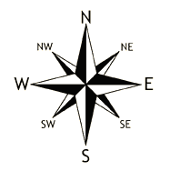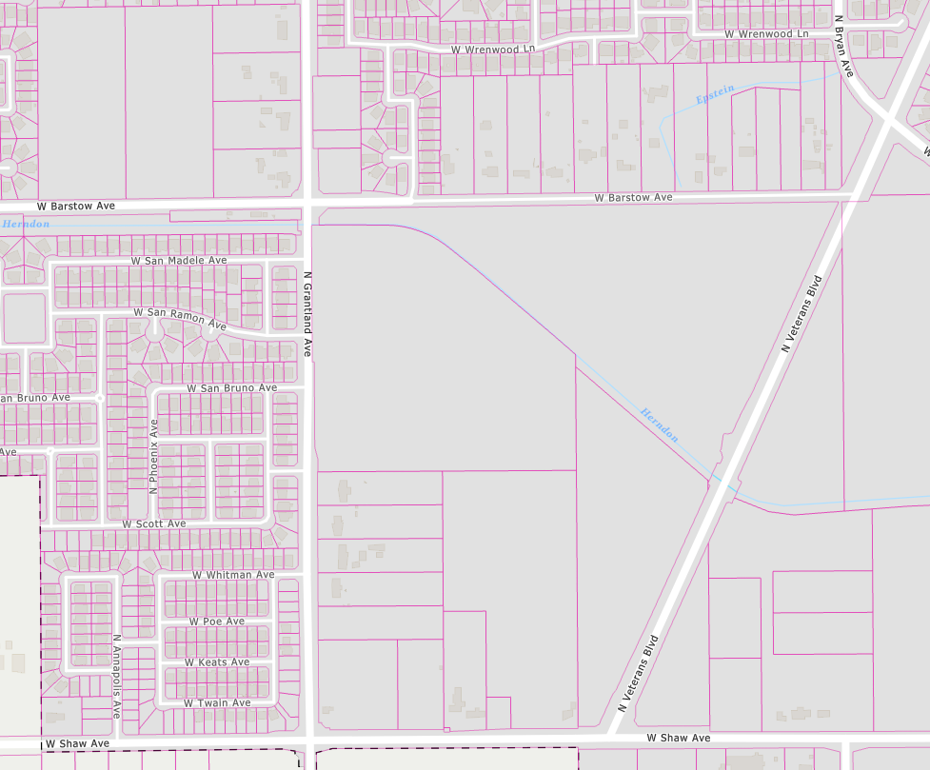

Subject Property

