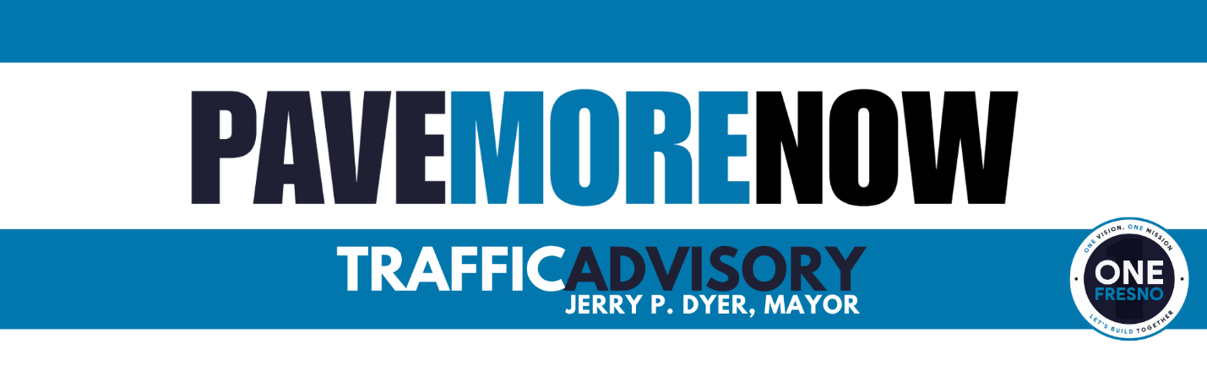
October 15, 2025 | CONTACT: Sontaya Rose, Director of Communications  (559) 903-7026

REPAVING FIRST STREET – BULLARD TO SIERRA
FRESNO, CA- As part of Mayor Jerry P. Dyer’s Pave More Now initiative, the City of Fresno is repaving First Street between Bullard and Sierra starting Monday, October 20, 2025. Work will take place overnight to minimize impacts to daytime traffic and nearby schools, including Ahwahnee Middle School.
Drivers should expect lane reductions and a brief intersection closure at First and Bullard for repaving.
Construction Schedule
- Monday, October 20 (8 pm – 6 am) – Manhole work – both northbound and southbound lanes
- Tuesday, October 21 (8 pm – 6 am) – Grinding – both northbound and southbound lanes
- Wednesday, October 22 (8 pm – 6 am) – Repaving – both northbound and southbound lanes
- Thursday, October 23 (8 pm – 6 am) – Grind and Pave Bullard & First intersection – intersection closed, follow posted detour routes
- Sunday, October 26 – (8 pm – 6 am) – Addition manhole work – both directions
- Tuesday, October 28 – 29 – (8 pm – 6 am) – Striping both northbound and southbound lanes

The schedule is subject to construction or weather delays. For questions, please call 311 or visit fresno.gov/PaveMoreNow

###

