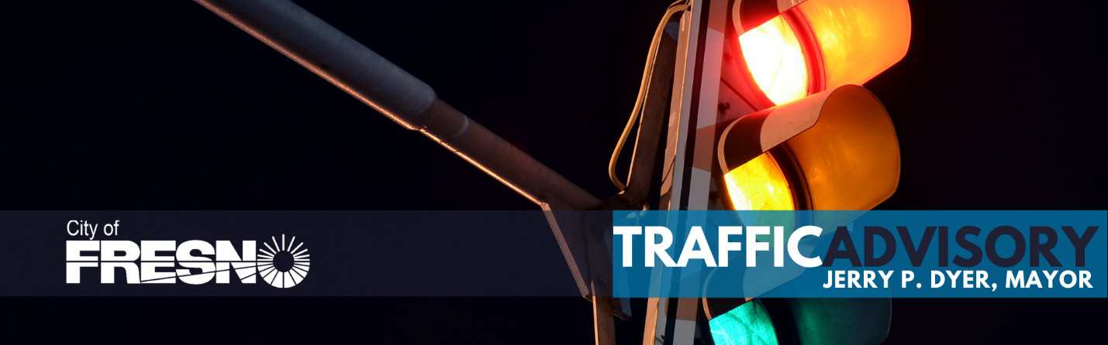
October 9, 2025 | CONTACT: Sontaya Rose, Director of Communications  (559) 903-7026

PAVE MORE NOW – SHAW & BRAWLEY INTERSECTION CLOSURE
FRESNO, CA- As part of Mayor Jerry P. Dyer’s Pave More Now initiative, the City of Fresno is continuing with major paving work on Shaw Avenue between Blythe and Valentine Avenues. Starting Sunday night, October 12, 2025, at 8 pm, the intersection of Shaw and Brawley will be completely closed for intersection repaving. This work is being conducted during the overnight hours to minimize impacts on daytime traffic and the commercial corridor.
Construction throughout Shaw Avenue is scheduled to continue through Friday, October 24, 2025, pending any unforeseen delays or weather conditions prohibiting construction. Businesses along Shaw Avenue will remain accessible and drivers are encouraged to use alternate routes or expect delays during construction hours. Please see map attached.
For questions, please call 311 or visit fresno.gov/PaveMoreNow




