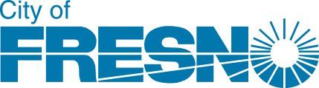

**Planning and Development Department**

**Community Development Division (CDD)**

**August 18, 2025**

2025-2026 Community Services NOTICE OF FUNDING AVAILABILITY (NOFA) HANDBOOK

* **Community Services**
  + Community Development Block Grant (CDBG) Non-Homeless Public Services

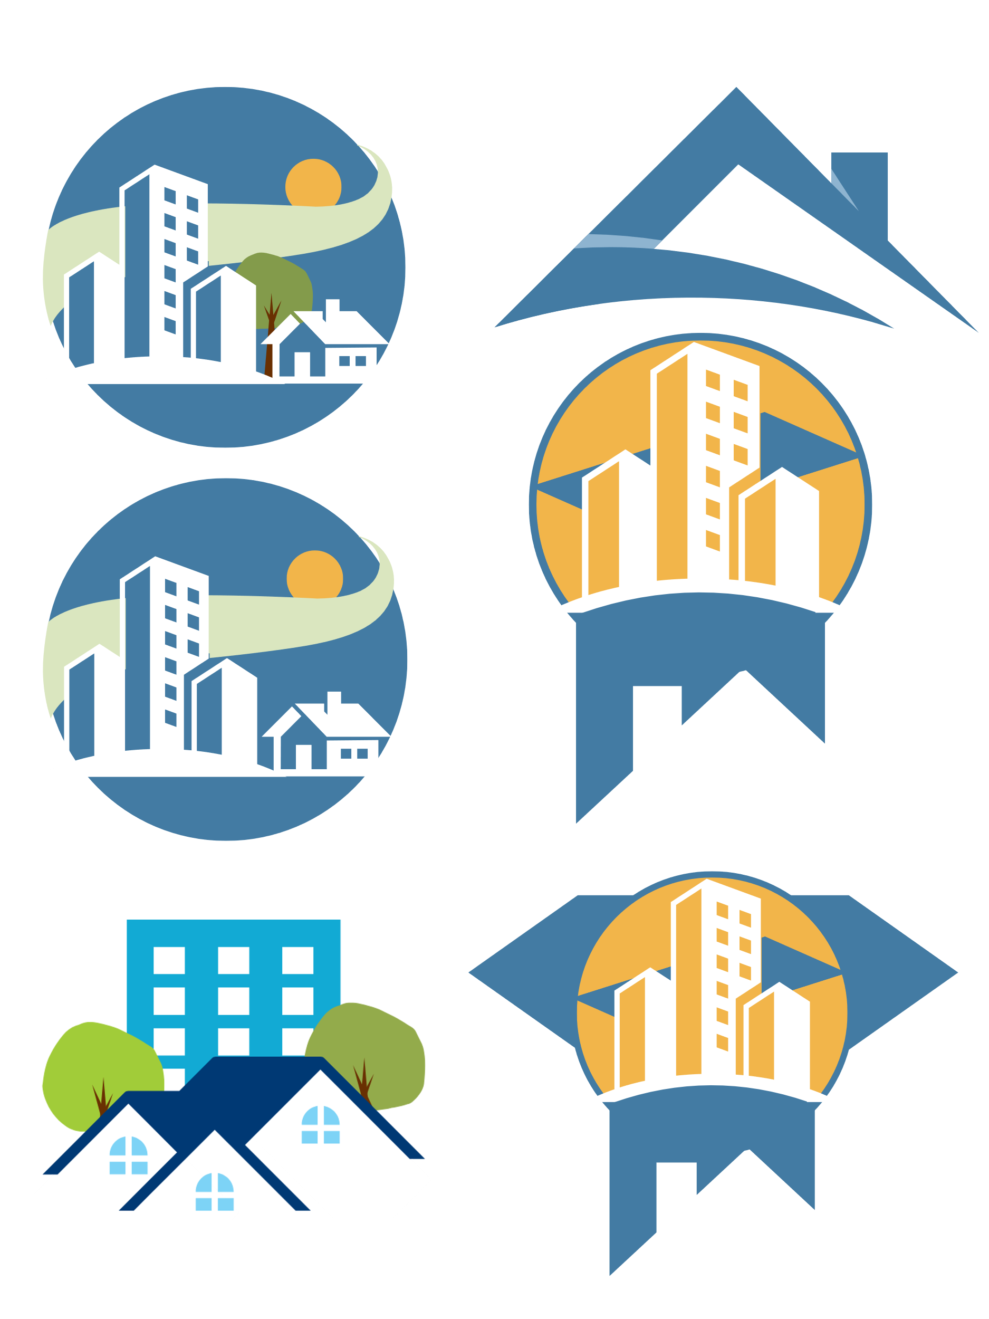

# Table of Contents

Table of Contents 2

Application Submission 3

Introduction 4

Invitation 5

Threshold Eligibility Requirements 6

Application Period Support 9

Appendix A: CDBG Program Description 10

Appendix E: CDBG National Objectives 14

Appendix F: Income Limits 18

Appendix G: Racially/Ethnically Concentrated Areas of Poverty (RECAPs) 19

# Application Submission

***Application Deadline*September 12, 2025, by 5 PM**

*Application Delivery*

1. **Ple**ase submit an electronic version of your application by:

Email [HCDD@fresno.gov](mailto:HCDD@fresno.gov), or

If your file is over 40 MB, email [HCDD@fresno.gov](mailto:HCDD@fresno.gov) to receive a link for large file submission

Hard copies of applications and authorizing resolutions are not requested or accepted. If assistance is required for digital submission, please reach out to the contact listed below.

We will email you within one business day of receipt to confirm application submission – if you do not receive a confirmation, please contact the relevant person below:

*Contact Person*

* **Community Services**  
  Kimberly Archie | 559-621-8458 | [kimberly.archie@fresno.gov](mailto:kimberly.archie@fresno.gov)

Community Development Division | 559-621-8300 | [HCDD@fresno.gov](mailto:HCDD@fresno.gov)

# Introduction

The purpose of this handbook is to guide interested parties through the City of Fresno’s Community Services Notice of Funding Availability (NOFA) for program year 2025-2026 (PY 2025). This handbook provides a general overview of the NOFA process and applicable requirements for informational purposes only. **It is not intended to be a full disclosure of all applicable Federal, State and/or local rules, regulations, procedures, and/or reporting requirements.**

The proposals submitted in response to the NOFA must align with the goals to be outlined in the City’s 2025-2029 Consolidated Plan. Selections made through this NOFA will be incorporated into the 2025-2026 Annual Action Plan through a substantial amendment which will allocate $200,000 of the City’s annual CDBG entitlement funding from the U.S. Department of Housing and Urban Development’s Office of Community Planning and Development (HUD CPD). The goal for Community Services is:

Invest in the community by providing services to low- and moderate-income individuals that promote well-being and improved quality of life through projects and activities that support children and families, people experiencing or at-risk of homelessness, victims of domestic violence, or other non-homeless special needs groups.

The HUD entitlement funded program allocated through the Annual Action Plan for Community Services is:

* **Community Development Block Grant (CDBG)**  
  Since 1974, the CDBG Program has provided a flexible source of annual funding to communities nationwide. The program offers local governments, with citizen participation, the opportunity to fund certain projects, programs, and/or public services provided that these meet one of the following three National Objectives: 1) benefit low/moderate-income (LMI) persons; 2) prevent or eliminate slums and blight; or 3) meets an urgent need. In the case of the City, all CDBG-funded projects and programs must meet the National Objective of benefiting LMI persons.

# Invitation

The City has $200,000 in CDBG funds available for Community Services that serve predominantly low- and moderate-income clientele. Interested nonprofit organizations and eligible governmental entities are invited to submit proposals for funding for the 2025-2026 program year. This funding invitation seeks proposals for programs, services, projects, and activities that:

* Address the Community Services goal outlined in the 2025-2029 Consolidated Plan as described above,
* Consist of eligible activities according to Federal regulations governing the respective funding source, and
* Address the needs of the community as stated through the City’s community needs workshops and identified as priority objectives in each Application.

An organization’s completed application includes one Part A (Cover Page), and one or more Part B (Application) including all relevant exhibits and attachments. The City has prepared the Application to correspond to the key goal that is outlined in the 2025-2029 Consolidated Plan to allow for a standardized method of evaluation based on the type of program, project, or activity.

Organizations selected to receive funding through this NOFA must be approved by the Fresno City Council and will be considered subrecipients in accordance with 2 CFR 200.331. (see e-CFR citation at: <https://www.ecfr.gov/current/title-2/section-200.331>)

# Threshold Eligibility Requirements

Each proposed project, program, or activity to be funded during PY 2025 must meet each of the threshold criteria listed below. If City staff reviews the proposal and cannot determine, strictly based on the information presented, how one or more of the criteria will be met the proposal will be deemed ineligible and will not be forwarded for consideration.

1. **Eligible Entity.** An eligible entity is:

* A unit of local government serving program beneficiaries residing in the city of Fresno, or;
* A nonprofit corporation that: 1) is incorporated in California or incorporated with a State of the United States, the District of Columbia or a United States Territory and properly registered as a “Foreign Corporation” with the California Secretary of State; and 2) possesses a 501(C)(3) determination of exempt status. The City will accept an advance determination ruling from the IRS.

1. **2025-2026 NOFA Part A – Cover Page**. Each applicant must submit a fully completed and signed 2025-2026 NOFA Cover Page by the deadline provided herein. There are two versions of the Cover Page which correspond to the type of entity – Non-Profit Organization, or Unit of Government.

The Cover Page must, without exception, include the applicant’s Unique Entity Identifier (UEI) number. A UEI number is the primary means of entity identification for Federal awards government-wide. The Federal government uses the UEI number to track how Federal money is allocated. If your organization does not have a UEI number visit the SAM.gov website at: <https://sam.gov/content/duns-uei>  
  
Registering for a UEI number is free of charge. To see comprehensive instructions and checklists for entity registration visit: <https://sam.gov/content/duns-uei>. Click on “Entity Registration Checklist”

1. **2025-2026 NOFA Part B - Application**. Submit the corresponding NOFA Application (per Table 1 above) for each NOFA project activity for which funding is being sought.

Notes:

* Applicants proposing multiple activities that utilize one funding source must submit separate proposals for each activity; however, only one Cover Page is needed.
* Each activity seeking a Low/Mod Income Presumed Benefit by Nature and Location National Objective must submit a separate NOFA Application for each location. (Note: Any Applicant seeking Presumed Benefit by Nature and Location must discuss with your City NOFA category contact person prior to application submittal.)

1. **Consolidated Plan Priorities**: The proposal must clearly target the Community Services goal of the City’s 2025-2029 Consolidated Plan (see Introduction).
2. **Community Need Identified:** Proposals that clearly address the needs identified by the community through the City’s community needs meetings and hearings as indicated as priority objectives in the Application will be given preference.
3. **Eligible Activity**: Each proposal must: (1) implement an eligible activity, (2) serve eligible beneficiaries, (3) achieve an eligible objective, (4) have a reasonable cost, and (5) be completed in a timely manner. These five considerations are found in the HUD regulations at links provided in the below table. Additionally, the CDBG program is subject to all Presidential Executive Orders and the Office of Management and Budget Guidance for Federal Financial Assistance found at 2 CFR 200. **Please note that 2 CFR 200 was recently updated.**

CDBG program regulations at 24 CFR 570 –

<https://www.ecfr.gov/cgi-bin/text-idx?tpl=/ecfrbrowse/Title24/24cfr570_main_02.tpl>

Office of Management and Budget Guidance for Federal Financial Assistance at 2 CFR 200 (updated) –

<https://www.ecfr.gov/current/title-2/subtitle-A/chapter-II/part-200?toc=1>

Presidential Executive Orders – <https://www.federalregister.gov/presidential-documents/executive-orders>

1. **Eligible Expenses**: Each proposal must budget only for ‘eligible expenses’ consistent with the applicable provisions of the program regulations identified above. A budget narrative describing the types of expenses included in each line item shall be included with the Application.
2. **Financial and Management Systems**: Each subrecipient must complete the Financial and Management Systems question section of the 2025-2026 NOFA Cover Page. Failure to answer the questions/requests for information or to provide answers consistent with good financial management practices may disqualify the applicant for funding. Successful applicants will be required to submit evidence that the person or people overseeing the project or program has completed the HUD Exchange online Financial Management 101, 201, and the applicable Advanced Financial Management webinars and passed the associated tests/quizzes with an acceptable score. The curriculum can be found at <https://www.hudexchange.info/trainings/financial-management-curriculum/>. A certificate issued by HUD or a transcript printed from the manager’s/supervisor’s HUD Exchange account will be needed prior to executing an agreement with the City. Additionally, selected subrecipients will be required to participate in mandatory technical assistance training provided by the City before the start of the program year. Failure to attend the mandatory training may disqualify an entity from funding.
3. **Active & in Good Standing**: Non-profit organizations must be registered and in good standing with the IRS, State of California Secretary of State, State of California Office of Attorney General, and the federal government. City staff will verify organizations’ status on the following web sites, and any missing filings, ‘inactive’, ‘delinquent’, or ‘excluded’ statuses will be grounds for disqualification failing sufficient explanation by the applicant.

* IRS: <https://www.irs.gov/charities-non-profits/tax-exempt-organization-search>
* California Secretary of State: <https://bizfileonline.sos.ca.gov/search/business>
* California Office of the Attorney General: <https://rct.doj.ca.gov/Verification/Web/Search.aspx?facility=Y>
* [Entity Registration | SAM.gov](https://sam.gov/entity-registration)

1. **No Open or Unresolved Findings with the City’s Community Development Division**: Any current or previous City of Fresno subrecipient for whom a monitoring finding is currently open and unresolved will be disqualified. Staff reserves the right to recommend exceptions for subrecipients who are actively working to resolve the findings.
2. **Location of Activities**: All activities funded with CDBG funds for Community Services must be located in and benefit residents of the City of Fresno.

**Important Additional Notes**

* **Pre-Award Cost**

Applicants should note that any premature commitment or expenditure of funds for proposed activities is prohibited. No project expenses will be eligible for reimbursement if they have been incurred or commissioned prior to a completed environmental review and clearance by the City. Project expenses will also not be eligible for reimbursement if they have been incurred or commissioned prior to the commencement date identified in the executed subrecipient agreement with the City.

# 

# Application Period Support

The City is committed to encouraging and supporting as many eligible proposals from as many different applicants as possible. Applicants may schedule a one-on-one meeting with City staff for technical assistance. Appointments are required and times will be based on City staff availability. To request a meeting, please contact Kimberly Archie, Senior management Analyst, at [Kimberly.Archie@fresno.gov](mailto:Kimberly.Archie@fresno.gov).

General inquiries may be sent to [HCDD@fresno.gov](mailto:HCDD@fresno.gov).

**Appendices**

# Appendix A: CDBG Program Description

The Community Development Block Grant (CDBG) program is administered by HUD and is authorized under Title 1 of the Housing and Community Development Act of 1974, as amended. The purpose of the CDBG Program is to enhance and maintain viable urban communities through the provision of decent housing, a suitable living environment, and the expansion of economic opportunities, principally for low- and moderate-income persons.

Programs and activities proposed for CDBG funding must be located within the city limits, include only eligible uses of funds, and meet at least one of the following national objectives.

**National Objective No. 1 – Activities Benefiting Lower Income Persons/Households**

The definition of a lower income person or household is one having an income equal to or less than 80 percent of the Fresno Area median income, as established by HUD. Income levels are provided in a later section of this handbook. All CDBG awarded subrecipient activities are required to serve low- to moderate-income persons. Activities benefiting lower income persons/households fall into four categories: area-benefit activities, limited clientele activities, housing activities, and job activities.

Area-Benefit Activities: Activities that serve geographic areas in which at least 51% of the households are lower income based on census data. Examples of Area Benefit Activities include public improvements, (i.e., street, sidewalk, curb, gutter improvements), park improvements, community centers, and public facilities (including related design and engineering work).

Limited Clientele Activities: Under Low/Mod Limited Clientele (LMC), benefits are provided to a specific group of eligible persons rather than every person in a defined service area. To qualify as a limited clientele activity, at least 51 percent of the beneficiaries of the activity must be low/mod income. An LMC activity must meet one of the following tests:

1. Exclusively benefit clientele who are generally presumed by HUD to be principally low/mod income persons; specifically abused children, battered spouses, elderly persons, adults with severe disabilities, homeless persons, illiterate adults, persons living with AIDS, and migrant workers.
2. Benefit low/mod persons comprising at least 51 percent of the clientele served. Information on individual family size and income is required to show evidence that incomes to not exceed CDBG income limits.

Housing Activities: Housing activities include acquisition or rehabilitation of properties. CDBG funds may not be used for new housing construction. However, funds may be used for property acquisition and construction of off-site improvements in conjunction with new construction.

The City currently has a housing rehabilitation program for lower-income owner occupied units. People wanting more information about these programs should contact the Community Development Division at (559) 621-8300. Applications from individuals interested in these types of activities will not be accepted. Individuals will be redirected to the existing programs.

Job Activities: CDBG funds may be used to undertake certain economic development activities. Activities under this category are required to create and/or retain jobs for low- and moderate-income persons. There are stringent guidelines under this activity. It is advised that persons or organizations interested in this activity work directly with staff to ensure the parameters of the regulations are met.

**National Objective No. 2 – Activities That Aid in the Prevention or Elimination of Slums or Blight**

If a project cannot meet the low-income objective, a project may qualify if it benefits a slum or blighted area. State or local laws define slum and blighted areas as those that contain a high number of deteriorating or dilapidated buildings or infrastructure. Redevelopment project areas generally qualify under this category. Note: Most blighted areas also qualify under National Objective No. 1 (Activities Benefiting Lower-Income Persons/Households), and it is not necessary for you to spend time on the application justifying how you meet the special requirements for slums and blight.

To meet this objective, the activity must be located in a City redevelopment area or in an area where there is a substantial number of deteriorated or deteriorating buildings. The activity must be designed to address one or more of the conditions that qualified the area as slum/blighted.

Projects may qualify outside a slum or blighted area on a spot blight basis. Activities include acquisition, demolition, rehabilitation, relocation, and historic preservation. Under this standard, rehabilitation of a building or a house is limited, to the extent necessary, to eliminate the substandard conditions that are detrimental to public health and safety.

The City’s 2025-2029 Consolidated Plan indicates that all of the City’s entitlement funds will benefit low- and moderate-income individuals/households. The City will not accept applications through this NOFA that meet only the national objective of preventing or eliminating slum and blight.

**National Objective No. 3 – Activities Designed to Meet Community Development Needs Having a Particular Urgency**

Activities must be designed to alleviate existing conditions that pose a serious and immediate threat to the health or welfare of the community that became urgent within the past 18 months. The City must demonstrate that other sources of funding are not available. Again, projects that meet either National Objective No. 1 or 2 do not need to meet this objective.

The City’s 2025-20209 Consolidated Plan indicates that all of the City’s entitlement funds will benefit low- and moderate-income individuals/households. The City will not accept applications through this NOFA that meet only the national objective of meeting community development needs having a particular urgency.

**Eligible CDBG Activities**

In addition to meeting one of the above national objectives, the activity must also be an eligible use of CDBG funds. Eligible activities include, but not limited to, the following:

* Acquisition, design, construction, and/or rehabilitation of a structure that will conduct a CDBG eligible activity.
* Public facility improvements such as: parks, playgrounds, recreational, senior and youth centers, except 24-hour care facilities.
* Street improvements including curbs, gutters, sidewalks, lights, and street paving.
* Water system improvements including fire hydrants.
* Flood, drainage, or sewer facilities.
* Acquisition of property that is of historic value; appropriate for beautification or conservation of open spaces; or appropriate for low- or moderate-income housing.
* Elimination of conditions that are detrimental to health, safety and public welfare through interim rehabilitation such as: demolition of buildings and clearance of land that may be a health hazard to the community.
* Interim assistance or temporary help to alleviate harmful or dangerous conditions.
* Removal of architectural barriers that restrict mobility of persons with disabilities.
* Conservation and improvement of the housing stock through rehabilitation of homes belonging to lower-income persons.
* Assistance to lower income first-time home buyers.
* Rehabilitation and preservation of buildings and improvements, both publicly and privately owned.
* Eligible planning and environmental design cost.
* Eligible economic development activities, such as creation of jobs for persons of low and moderate income through the expansion of business opportunities by providing financial incentives to small businesses. Note: There are additional Federal requirements for qualifying projects under this provision. Interested persons should discuss their proposal with City staff prior to applying.
* Public Services - Expansion and improvement in the quantity and quality of public services, principally for lower income persons. A maximum of 15 percent of the City's total annual CDBG allocation may be used for public service activities. Examples of public services include:
  + After school programs, crime prevention, childcare, health care, job training, recreation, education, fair housing, senior citizen programs, homeless services, drug-abuse related services, energy conservation, home buyer assistance and social services (excluding provision of income payments).
  + Note: to utilize CDBG funds for a public service, the service must be either a new service or a quantifiable increase in the level of an existing service. Specifically, this provision applies in the following manner:
    - If a service is new, it may be funded.
    - If a service is existing, determine whether it was provided by or on behalf of the City with local or state funding.
    - If it was not provided by or on behalf of the City with funding from the local government, it may be funded.
    - If it was provided by or on behalf of the City with funding from the local government, the City must determine whether the proposed service will be a quantifiable increase in the level of service. If it can be documented that the service is a quantifiable increase in the level of service, it may be funded.
    - The regulations do not prohibit the City from continuing to provide funding to a CDBG-funded public service at the same or decreased level in subsequent program years.

**Ineligible CDBG Activities**

* Buildings for the general conduct of government such as city halls, courthouses, and police stations (Note: Police substations may be built in CDBG eligible areas.)
* Stadiums, sports arenas, auditoriums, museums, and central libraries (Note: Branch libraries and community centers may be built in CDBG eligible areas.)
* Airports, subways, bus or other stations.
* Expenses of general government for operation and maintenance of public facilities.
* Direct income payments to residents.
* New housing construction (except when done by a community-based development organization recognized by HUD.)

# Appendix E: CDBG National Objectives

| **National Objective (NOC)** | **Description** | **24 CFR Citation** |
| --- | --- | --- |
| LMA | Low/mod area benefit  Activities providing benefits that are available to all the residents of a particular area, at least 51% of whom are low/mod income. The service area of a LMA activity is identified by the grantee and need not coincide with Census tracts or other officially recognized boundaries. | 570.208(a)(1) |
| LMAFI | Low/mod area benefit, community development financial institution (CDFI)  Job creation and retention activities that are carried out by a CDFI and that the grantee elects to consider as meeting the low/mod area benefit criteria. | 570.208(d)(6)(i) |
| LMASA | Low/mod area benefit, neighborhood revitalization strategy area (NRSA)  Job creation and retention activities that are carried out pursuant to a HUD-approved Neighborhood Revitalization Strategy (NRS) and that the grantee elects to consider as meeting the low/mod area benefit criteria. | 570.208(d)(5)(i) |
| LMC | Low/mod limited clientele benefit  Activities that benefit a limited clientele, at least 51% of whom are low/mod income. LMC activities provide benefits to a specific group of persons rather than to all the residents of a particular area. | 570.208(a)(2) |
| LMCMC | Low/mod limited clientele, micro-enterprises  Activities carried out under 24 CFR 570.201(o) that benefit micro-enterprise owners/developers who are low/mod income. | 570.208(a)(2)(iii) |
| LMCSV | Low/mod limited clientele, job service benefit  Activities that provide job training, placement and/or employment support services in which the percentage of low/mod persons assisted is less than 51%, but the proportion of the total cost paid by CDBG does not exceed the proportion of the total number of persons assisted who are low/mod. | 570.208(a)(2)(iv) |
| LMH | Low/mod housing benefit  Activities undertaken to provide or improve permanent residential structures that will be occupied by low/mod income households. | 570.208(a)(3) |
| LMHSP | Low/mod housing benefit, CDFI or NRSA  Activities carried out by a CDFI or pursuant to a HUD- approved Neighborhood Revitalization Strategy (NRS) to provide or improve permanent residential structures that the grantee elects to consider as a single structure for purposes of determining national objective compliance. For example, two single-unit homes rehabilitated in an NRS may be considered a single structure; at least one of the units must be occupied by a low/mod household. If ten single-unit homes were assisted, at least six (51%) must be occupied by low/mod households. | 570.208(d)(5)(ii)  and (d)(6)(ii) |
| LMJ | Low/mod job creation and retention  Activities undertaken to create or retain permanent jobs, at least 51% of which will be made available to or held by low/mod persons. | 570.208(a)(4) |
| LMJFI | Low/mod job creation and retention, public facility/ improvement benefit  Public facility/improvement activities that are undertaken principally for the benefit of one or more businesses and that result in the creation/retention of jobs. | 570.208(a)(4)(vi) (F) |
| LMJP | Low/mod job creation, location-based  Activities where a job is held by or made available to a low/mod person based on the location of the person’s residence or the location of the assisted business. | 570.208(a)(4)(iv) |
| SBA | Slum/blight area benefit  Activities undertaken to prevent or eliminate slums or blight in a designated area. | 570.208(b)(1) |
| SBR | Slum/blight, urban renewal areas  Activities authorized under an Urban Renewal Loan and Grant Agreement that are undertaken to prevent or eliminate slums or blight in an urban renewal area and that are necessary to complete an Urban Renewal Plan. | 570.208(b)(3) |
| SBS | Slum/blight, spot basis  Activities undertaken on a spot basis to address conditions of blight or physical decay not located in designated slum/blight areas. | 570.208(b)(2) |
| URG | Urgent need  Activities that alleviate emergency conditions of recent origin that pose a serious and immediate threat to the health or welfare of the community; eligible only if the grantee cannot finance the activity on its own and no other sources of funding are available. | 570.208(c) |

# Appendix F: Income Limits

|  |  |  |  |
| --- | --- | --- | --- |
| **Household Size** | **30% AMI** | **50% AMI** | **80% AMI** |
| 1 | $19,750 | $32,900 | $52,600 |
| 2 | $22,550 | $37,600 | $60,100 |
| 3 | $25,350 | $42,300 | $67,600 |
| 4 | $28,150 | $46,950 | $75,100 |
| 5 | $30,450 | $50,750 | $81,150 |

CDBG income limits are effective as of June 1, 2025. View the most current CDBG income limits at <https://www.hudexchange.info/resource/5334/cdbg-income-limits/>

# Appendix G: Racially/Ethnically Concentrated Areas of Poverty (RECAPs)

The application awards additional points for projects that are targeted to areas designated by HUD as Racially/Ethnically Concentrated Areas of Poverty (RECAPs). The below map indicates the location of these census tracts within the City (shaded areas). If you are unsure if the location of your proposed activity is within a RECAP tract, contact us for support.

**