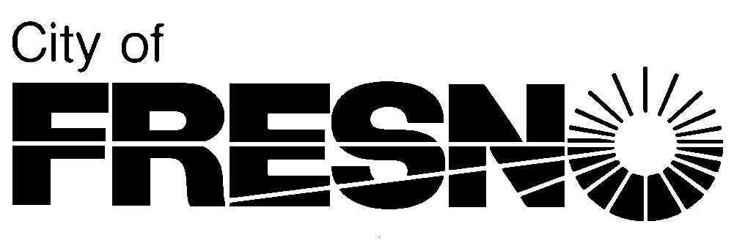

2600 Fresno Street, Third Floor **Planning and Development Department**

Fresno, California 93721 **Jennifer K. Clark, AICP, Director**

(559) 621-8277

________, 2022 *Please reply to:*

Planner Name

(559) 621-____

Applicant

City of Fresno

[*Applicant@fresno.gov*](mailto:Applicant@fresno.gov)

Sent via email only

**SUBJECT: ENVIRONMENTAL ASSESSMENT APPLICATION NO. PXX-XXXXX REGARDING [BRIEF DESCRIPTION] FOR PROPERTY LOCATED AT ADDRESS (APN: XXX-XXX-XX)**

Dear Applicant:

Staff has reviewed the proposed project and has determined that there is no substantial evidence that the project may cause a significant effect on the environment, therefore a Negative Declaration was prepared. The Negative Declaration was prepared in compliance with Sections 15070 to 15075 of the California Environmental Quality Act (CEQA) Guidelines.

A public review period of 20 days was provided pursuant to Section 15105 of the CEQA Guidelines. The public review period started on [enter date] and ended on [enter date]. No comments from the public were received.

The [enter City department name] Department may move forward with the adoption of the Negative Declaration. Once the City approves or determines to carry out the project (i.e., City Council approval), a Notice of Determination (NOD) **shall** be filed with the Fresno County Clerk within five working days. The filing of a NOD starts a 30-day statute of limitations on court challenges. Planning staff has prepared a draft NOD for your use in filing. Please note that the Fresno County Clerk charges a filing fee. The fee is currently $50. The filing of a Negative Declaration also requires payment of an environmental document filing fee to the California Department of Fish and Wildlife (CDFW). Please visit the [CDFW website](https://wildlife.ca.gov/Conservation/Environmental-Review/CEQA/Fees) for filing fee costs. Please note these fees increase annually. Payment of the CDFW is paid to the Fresno County Clerk and due when the NOD is filed.

Should you need further assistance or have any questions, please call me at the phone number indicated above.

Sincerely,

______________, Planner

Development Services Division

Enclosures: Environmental Assessment for a Negative Declaration

Draft Notice of Determination