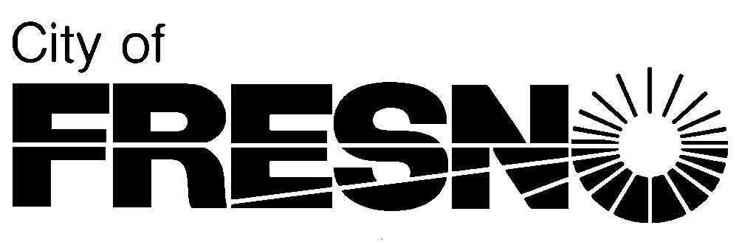

2600 Fresno Street, Third Floor **Planning and Development Department**

Fresno, California 93721 **Jennifer K. Clark, AICP, Director**

(559) 621-8277

________, 2022 *Please reply to:*

Planner Name

(559) 621-____

Applicant

City of Fresno

[*Applicant@fresno.gov*](mailto:Applicant@fresno.gov)

Sent via email only

**SUBJECT: ENVIRONMENTAL ASSESSMENT APPLICATION NO. PXX-XXXXX REGARDING [BRIEF DESCRIPTION] FOR PROPERTY LOCATED AT ADDRESS (APN: XXX-XXX-XX)**

Dear Applicant:

A preliminary determination has been made that the proposed project is categorically exempt from environmental review under Section 153XX/Class XX of the California Environmental Quality Act (CEQA) Guidelines. Therefore, a categorical exemption has been issued, a copy of which is enclosed. [only for vacations - Please be advised that the proposed vacation is subject to the conditions established through a Vacation Feasibility Study (ref: Public Works Department File No. XXX).]

The categorical exemption was completed by Planning staff on [enter date on exemption]. Once the City approves or determines to carry out the project (i.e., City Council approval), a Notice of Exemption (NOE) may be filed with the County Clerk. The filing of a NOE begins a 35-day statute of limitations period on legal challenges. If a NOE is not filed, a 180-day statute of limitations will apply. Planning staff has completed a draft NOE for your use in case a NOE is filed. Please note that the Fresno County Clerk charges a filing fee. The fee is currently $50.

Should you need further assistance or have any questions, please call me at the phone number indicated above.

Sincerely,

______________, Planner

Development Services Division

Enclosures: Categorical Exemption

Draft Notice of Exemption