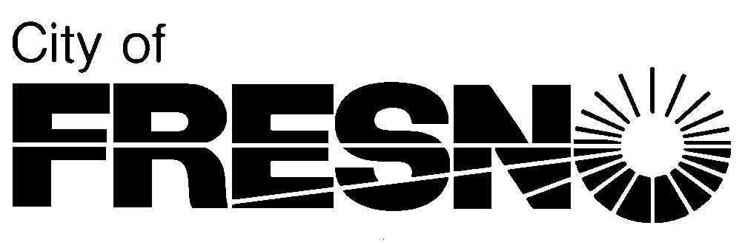 **Planning and Development Department**

2600 Fresno Street, Third Floor **Jennifer K. Clark, AICP, HDFP**

Fresno, California 93721 **Director**

(559) 621-8277

**[insert date]**

Robert Ledger

John Ledger

Eric S. Smith

Chris Acree

Dumna Wo Wah Tribal Government

2191 West Pico Avenue

Fresno, CA 93705

RE: Project Notification Pursuant to Assembly Bill 52 for Conditional Use Permit Application No. PXX-XXXXX in the City of Fresno, Fresno County

Dear Chairperson,

Pursuant to the provisions of Assembly Bill 52 (AB 52), which is described in more detail below, as the lead agency under the California Environmental Quality Act (CEQA), the City of Fresno hereby extends an invitation to consult on the CEQA review of the proposed Conditional Use Permit Application No. PXX-XXXXX in order to assist with identifying and/or preserving and/or mitigating project impacts to tribal cultural resources. A summary of the proposed project, including a map of the project location, is included as Exhibit A to this letter.

AB 52, which became law January 1, 2015, requires that, as part of the CEQA review process, public agencies provide early notice of a project to California Native American Tribes to allow for consultation between the tribe and the public agency. The purpose of AB 52 is to provide an opportunity for public agencies and tribes to consult and consider potential impacts to Tribal Cultural Resources (TCRs), as defined by the Public Resources Code (PRC) Section 21074(a).[1]¹ Outlined below is the general process for AB 52 compliance:

* *Pursuant to AB 52, tribes must formally request to the public agency in writing to be notified of projects within the jurisdiction of that public agency [Public Resources Code Section 5097.4]. Tribe requests in writing to the public agency to be notified of projects for which a Negative Declaration (ND), Mitigated Negative Declaration (MND), or Environmental Impact Report (EIR) is required;*
* *Following receipt of such request, the lead agency shall, within fourteen (14) days of determining that an application for a project is complete or a decision by a public agency to undertake a project shall provide formal notification to the designated contact of, or a tribal representative of, traditionally and culturally affiliated California Native American tribes that have requested notice [PRC Section 21080.3.1(d)];*
* *Upon notification from the lead agency, tribes have thirty (30) days to formally request consultation [PRC Section 21080.3(d)]; and,*
* *The lead agency shall initiate consultation within thirty (30) days of receiving the request for consultation [PRC Section 21080.3(e)].*
* *Consultation shall be considered concluded when either of the following occurs: (1) the parties agree to measures to mitigate or avoid a significant effect, if a significant effect exists, on a TCR; or (2) a party, acting in good faith and after reasonable effort, concludes that mutual agreement cannot be reached.*[2]²

If you would like to consult with the City pursuant to AB 52, **please respond in writing by 5:00 p.m. on [insert date]** to [Planner Name], [Planner Title], at [FirstName.LastName@fresno.gov](mailto:FirstName.LastName@fresno.gov) or 2600 Fresno Street, Room 3043, Fresno, CA 93721. Please include in your request, at a minimum, (1) name, title, and contact information of the tribal representative(s); (2) suggested dates and location of consultation; (3) any preliminary concerns or questions related to the project (optional).

If no written request is received by the aforementioned date, it will be assumed that you have declined consultation. If a request for consultation is received by the date above, the City will follow up within thirty (30) days to set up a date and location for consultation.

Thank you for your consideration on this matter and please do not hesitate to contact me at should you have any questions or need additional information.

Sincerely,

[Planner Name]

[Planner Title]

Attachment: Exhibit A: Project Description and Project Location Map

1. ¹ PRC Section 21074(a) defines a Tribal Cultural Resource as either of the following:

   Sites, features, places, cultural landscapes, sacred places, and objects with cultural value to a California Native American tribe that area either (1) included or determined to be eligible for inclusion in the California Register of Historical Resources; or (2) included in a local register of historical resources as defined in subdivision (k) of PRC Section 5020.1; or

   A resource determined by the lead agency, in its discretion and supported by substantial evidence, to be significant pursuant to criteria set forth in subdivision (c) of PRC Section 5024.1.
2. ² If consultation is conducted, the City, as lead agency, shall ensure that, unless provided with written consent by the consulting tribe, information exchanged during consultation will remain confidential for the purposes of preventing looting, vandalism, or damage to tribal cultural resources and shall not disclose third party confidential information regarding tribal cultural resources [PRC Section 21082.3].