CITY OF FRESNO

PLANNING AND DEVELOPMENT DEPARTMENT

**NOTICE OF ACTION GRANTING**

**CONDITIONAL USE PERMIT APPLICATION NO. P22-XXXXX & RELATED ENVIRONMENTAL ASSESSMENT**

NOTICE IS HEREBY GIVEN that the Planning and Development Department Director, in accordance with Fresno Municipal Code (FMC) Section 15-5009, has approved Conditional Use Permit Application No. P22-XXXXX and Environmental Assessment No. P22-XXXXX filed by _____ on behalf of _____, pertaining to a ±X.XX acre parcel of property located at ______, on the _____. The applicant requests authorization to _____. The project also includes a determination that the proposed project is exempt from the California Environmental Quality Act (CEQA) through Class 1 and Class 3 Categorical Exemptions dated January 1, 2022. The property is zoned O *(Office)*. The special permit has been granted subject to compliance with the Conditions of Approval, dated XXXX.*

*This document is available for review at the Planning and Development Department, located at 2600 Fresno Street, 3rd Floor, Fresno, California 93721. Documents are available for viewing at City Hall during normal business hours (Monday-Friday, 8 a.m.-5 p.m.) by appointment only. **Please contact the Planner listed below via e-mail or by phone to request electronic copies or schedule an appointment to view documents**.

Conditional Use Permit Application No. P22-XXXXX was granted subject to the following findings:

|  |  |
| --- | --- |
| **Findings per Fresno Municipal Code Section 15-5306** | |
| A Conditional Use Permit shall only be granted if the decision-maker determines that the project as submitted or as modified conforms to all of the following criteria. If the decision-maker determines that it is not possible to make all of the required findings, the application shall be denied. | |
| Finding a: | *The proposed use is allowed within the applicable zoning district and complies with all other applicable provisions of this Code and all other chapters of the Municipal Code;* |
| *a.* | |
| Finding b: | *The proposed use is consistent with the General Plan and any other applicable plan and design guideline the City has adopted;* |
| *b.* | |
| Finding c: | *The proposed use will not be substantially adverse to the public health, safety, or general welfare of the community, nor be detrimental to surrounding properties or improvements;* |
| *c.* | |
| Finding d: | *The design, location, size, and operating characteristics of the proposed activity are compatible with the existing and reasonably foreseeable future land uses in the vicinity; and,* |
| *d.* | |
| Finding e: | *The site is physically suitable for the type, density, and intensity of use being proposed, including access, emergency access, utilities, and services required.* |
| *e.* | |

NOTE: A Notice of Intent to Take Action (Neighborhood Notification) was sent to surrounding property owners pursuant to the requirements of Section 15-5007 of the FMC on January 1, 2022.

The Conditional Use Permit will not become effective until 15 days from the date the permit is granted in order to allow time for any interested parties to file an appeal.

In the event you wish to appeal the Director's decision, you may do so by filing a written appeal with the Director.  The appeal must include the appellant's interest in, or relationship to, the subject property, the decision or action appealed, specific reason(s) why the appellant believes the decision or action should not be upheld. An $873.65 fee applies to an appeal by an applicant (no fee applies if member of the public). **The fee is required prior to accepting the appeal, as required by Section 15-5017-A.1 of the FMC and established by the Master Fee Schedule.**

ANY WRITTEN appeal must be submitted to this office prior to close of business on **January 16, 2022**.

For additional information regarding this project, contact **Planner Name**, Planning and Development Department, by telephone at **(559) 621-XXXX** or via e-mail at [first.last@fresno.gov](mailto:first.last@fresno.gov). ***Si necesita información en Español, comuníquese con Jose Valenzuela al teléfono (559) 621-8070.***

PLANNING AND DEVELOPMENT DEPARTMENT

Jennifer K. Clark, AICP, HDFP, Director

Dated: January 1, 2022

Assessor’s Parcel No(s). XXX-XXX-XX

**SEE MAP BELOW**

****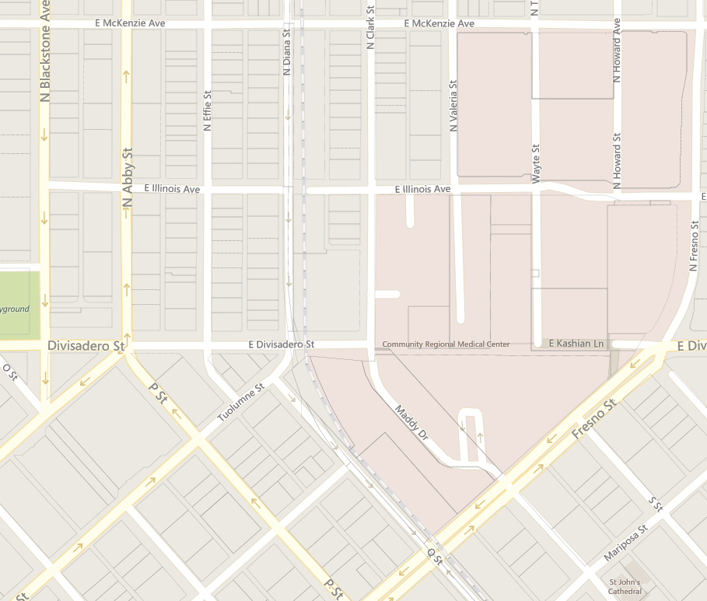

**Subject Property**

**LEGEND**

**Planning and Development Department**

**2600 Fresno Street, Room 3043 · Fresno, CA 93721 · Phone (559) 621-8277**