Development and Resource Management Department
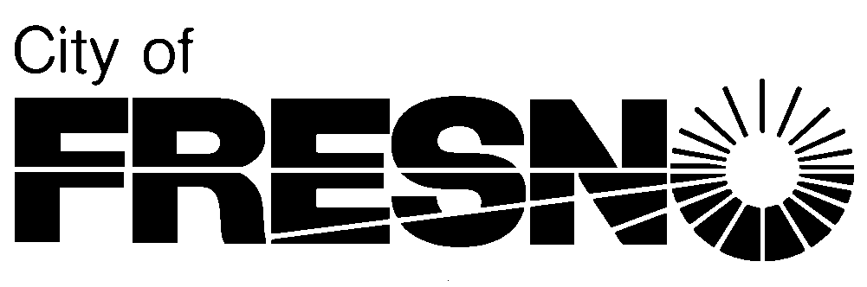
2600 Fresno Street-Third Floor Jennifer Clark, Director Fresno, California 93721-3604
(559) 621-8277 FAX (559) 498-1026

July 30, 2026
Please reply to:
Name
(559) 621-XXXX
FirstName.LastName@fresno.gov
Applicant
City of Fresno
Applicant@home.com
Sent via email only

SUBJECT: DEVELOPMENT PERMIT APPLICATION NO. D-17-XXX FOR PROPERTY LOCATED AT XX (aPN: XXX-XXX-XX)
Mrs. XX,

I wanted to take this opportunity to introduce myself as your assigned planner and primary point of contact throughout the processing of your entitlement application. As planners, our role is to ensure the implementation of the Fresno General Plan and relevant Community and Specific Plans. We also implement standards and regulations established by the Citywide Development Code and other applicable provisions of the Fresno Municipal Code through the review and approval of project specific entitlement applications.

Your project has been distributed to various city department and external agencies for their review and comment (if needed). Once project comments are submitted by the various departments\agencies, our permitting system (Accela, also known as Fresno FAASTER) will send you e-mail updates with these preliminary comments. To keep your project moving along in a timely manner, if you receive an e-mail with a status of Revisions Required or Additional Information Required, we ask that you carefully review these comments and redline notations and submit revised plans and documents. Your project will be placed on hold until these documents are received.

If you get an e-mail from a Department/Agency with the status of “Reviewed with Conditions”, no action on your part is needed. These conditions will be incorporated into your project conditions of approval when your project is approved or acted on by the Director.

We want to help you navigate the entitlement process and are committed to providing you with frequent communication through automated e-mails, through the Fresno FAASTER system (www.fresno.gov/faaster) and by phone when needed. We are also committed to the timely processing of your application. If at any point during this process you have questions regarding this project, please contact me at 621-XXXX or via e-mail at FirstName.LastName@fresno.gov.

If you are having trouble viewing documents or project status in the Fresno FAASTER system, please contact me and I will make sure that your public user account is linked to your project record in the system.

Since your project is a Level 3 project, our hope is to complete your project within 90 calendar days (June 15, 2017). If there are any delays or your project is placed on hold, we will let you know as soon as possible so that you always have a reasonable expectation of when your project will be completed.

Sincerely,

Name, Planner
Development and Resource Management Department

Sent via email to xx

