CITY OF FRESNO

PLANNING AND DEVELOPMENT DEPARTMENT

**NOTICE OF PUBLIC HEARING**

**CONDITIONAL USE PERMIT APPLICATION NO. P22-XXXXX AND RELATED ENVIRONMENTAL ASSESSMENT**

NOTICE IS HEREBY GIVEN that the Fresno City Planning Commission, in accordance with Sections 65090 and 65091 (Planning and Zoning Law) of the Government Code and in accordance with the procedures of Article 50, Chapter 15, of the Fresno Municipal Code (FMC), will conduct a public hearing to consider the items below, filed by _______ on behalf of _______, pertaining to a ±X.XX acre parcel of property located at [street address], on the northwest corner of East Clinton Avenue and North First Street:

1. **Environmental Assessment No. P22-XXXXX**: A determination that the proposed project is exempt from the California Environmental Quality Act (CEQA) through Class 1 and Class 3 Categorical Exemptions dated January 1, 2022.
2. **Conditional Use Permit Application No. P22-XXXXX:** A request for authorization to establish a State of California Alcoholic Beverage Control Type 20 alcohol license (*Package Store – sale of beer and wine for consumption off the premises where sold*) for a proposed convenience store.

## FRESNO CITY PLANNING COMMISSION

Date/Time: Wednesday, January 1, 2022 at 6:00 p.m. or thereafter

Place: City Hall Council Chamber, 2nd Floor, 2600 Fresno Street, Fresno, CA 93721; or, watch the live broadcast via the Zoom link located on the Planning Commission agenda found here: <https://fresno.legistar.com/Calendar.aspx>

In response to COVID-19, City Hall Council Chambers and City Hall will be open to the public at limited capacity for Planning Commission hearings to allow for social distancing. Any interested person may also participate electronically during the public hearing to speak in favor or against the project proposal, by either Zoom meeting or telephone with instructions provided on the Planning Commission Agenda, and present written testimony at least 24 hours in advance, via an eComment or by email to [PublicCommentsPlanning@fresno.gov](mailto:PublicCommentsPlanning@fresno.gov) (cc [first.last@fresno.gov](mailto:first.last@fresno.gov)). All documents submitted to the Planning Commission for its consideration prior to or at the hearing shall be submitted to the Planning Commission at least 24 hours prior to the Commission agenda item being heard, pursuant to the Planning Commission rules and procedures, or they may be excluded from the administrative record of proceedings.

If you challenge the above applications in court, you may be limited to raising only those issues, you, or someone else, raised at the public hearing described in this notice, or in written correspondence delivered to the Development Services Division of the Planning and Development Department and/or Planning Commission at, or prior to, the public hearing. The Planning Commission action on the proposed Conditional Use Permit and Environmental Assessment will be final unless appealed to the City Council. [highlighted language to change dependent upon applicable Review Authority per Code. Once you verify, delete comment in green highlight.]

NOTE: This public hearing notice is being sent to surrounding property owners within 1,000 feet of the project site pursuant to the requirements of FMC Section 15-5007.

All documents related to this project are available for public review at the Planning and Development Department at the address listed below or electronic copies may be requested by contacting the Planner at the number listed below.  Documents are available for viewing at City Hall during normal business hours (Monday-Friday, 8 a.m.-5 p.m.) by appointment only. **Please contact the Planner listed below via e-mail or by phone to request electronic copies or schedule an appointment to view documents.**

For additional information, contact **Planner Name**, Planning and Development Department, by telephone at **(559) 621-XXXX**, or via e-mail at [first.last@fresno.gov](mailto:first.last@fresno.gov). ***Si necesita información en Español, comuníquese con Jose Valenzuela al teléfono (559) 621-8070.***

PLANNING AND DEVELOPMENT DEPARTMENT

Jennifer K. Clark, AICP, HDFP, Director

Dated: XXXXXX

Assessor’s Parcel No(s). XXX-XXX-XX

**SEE MAP ON REVERSE SIDE**

**Planning and Development Department**

**2600 Fresno Street, Room 3043 · Fresno, CA 93721 · Phone (559) 621-8277**

 Planner Name

PLANNING AND DEVELOPMENT DEPARTMENT

2600 FRESNO STREET, ROOM 3043

FRESNO, CA 93721

**THIS IS A LEGAL NOTICE REGARDING**

[Project Address]

P22-XXXXX

**VICINITY MAP**

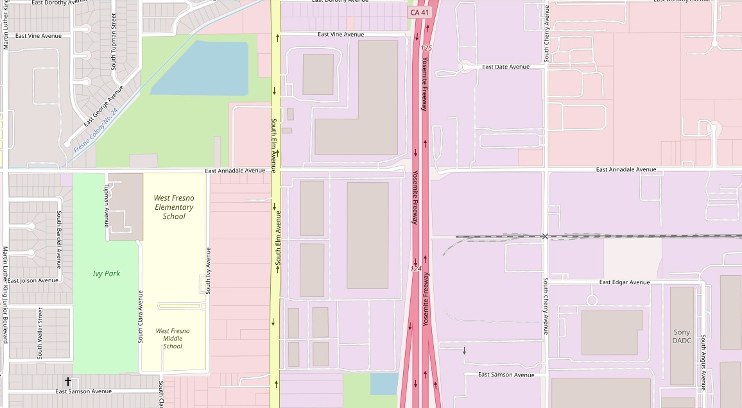

**Highway 41**

**S Elm Ave**

**E Chester/Samson Ave**

**E Vine Ave**

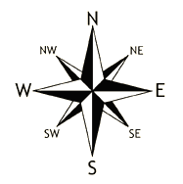

**Project Area**